**ASSIGNMENT 2:**

**ANSWER 2:**

**CODE:**

using System;

using System.Security.Cryptography.X509Certificates;

namespace ConsoleApp1

{

class Program

{

static void Main()

{

double[] charges = new double[7];

charges[0] = 2500;

Console.WriteLine("current charges " + charges[0]);

for (int i = 0; i < 6; i++)

{

charges[(i + 1)] = charges[i] + charges[i] * 4 / 100;

Console.WriteLine("Rate of year fees "+(i+1) + " are " + charges[(i + 1)]);

}

Console.ReadKey();

}

}

}

**OUTPUT:**

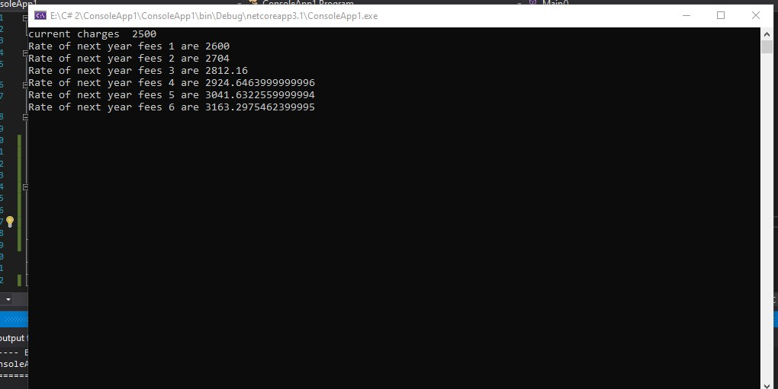

**ANSWER 3:**

**CODE:**

using System;

using System.Security.Cryptography.X509Certificates;

namespace ConsoleApp1

{

class Program

{

static void Main()

{

bool flag = true;

string ans;

while (flag)

{

Console.WriteLine("Are you crazy!");

ans = Console.ReadLine();

if (ans == "No" && ans == "no")

{

}

else if (ans == "yes" || ans == "YES" || ans == "Yes" || ans == "yES" || ans == "yeS")

{

flag = false;

}

}

Console.ReadKey();

}

}

}

**OUTPUT:**

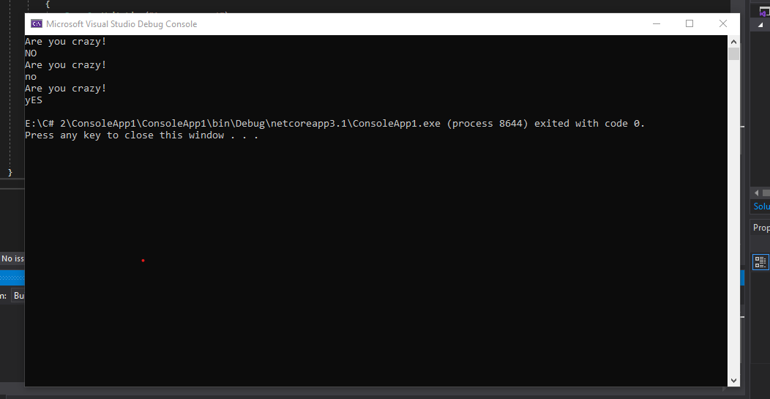

**ANSWER 4:**

**CODE:**

using System;

using System.Security.Cryptography.X509Certificates;

namespace ConsoleApp1

{

class Program

{

static void Main()

{

int pin, i = 0;

do

{

Console.WriteLine("Enter Your Pin:");

pin = Convert.ToInt32(Console.ReadLine());

i++;

} while (pin != 1234 && i < 3);

if (pin == 1234)

{

Console.WriteLine("correct pin");

}

else

{

Console.WriteLine("out of attempt");

}

Console.ReadKey();

}

}

}

**OUTPUT:**

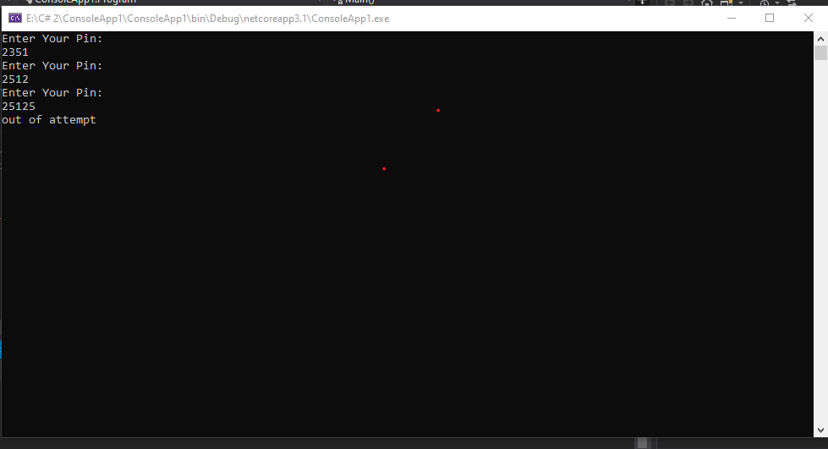

**ANSWER 5:**

**CODE:**

using System;

using System.Security.Cryptography.X509Certificates;

namespace ConsoleApp1

{

class Program

{

static void Main()

{

Random rnd = new Random();

int number = rnd.Next(1, 100);

int answer;

do

{

Console.WriteLine("Guess a number between 1 and 100");

answer = Convert.ToInt32(Console.ReadLine());

if (answer > number)

{

Console.WriteLine("Too high ");

}

else if (answer < number)

{

Console.WriteLine("Too low ");

}

else

{

Console.WriteLine("Congratulations! you figure out my numer");

}

} while (answer != number);

Console.ReadKey();

}

}

}

**OUTPUT:**

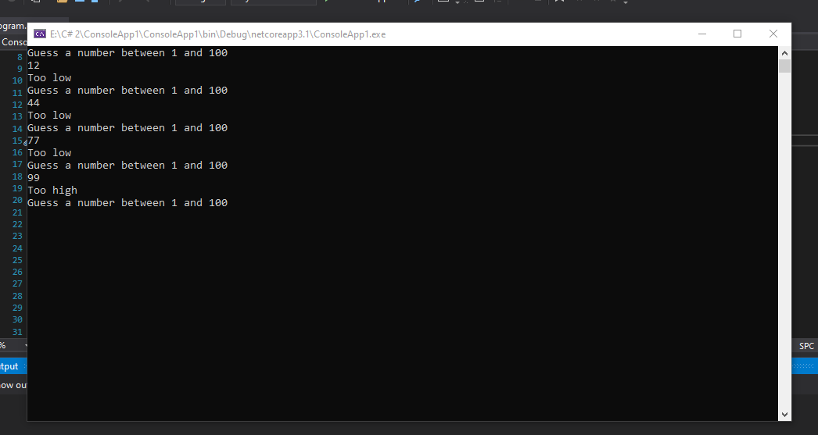

**ANSWER 7:**

**CODE:**

using System;

using System.Security.Cryptography.X509Certificates;

namespace ConsoleApp1

{

class Program

{

static void Main()

{

int[] sales = new int[3];

for (int i = 0; i < 3; i++)

{

Console.WriteLine("enter today’s sales for store " + (i + 1));

sales[i] = Convert.ToInt32(Console.ReadLine());

}

for (int i = 0; i < 3; i++)

{

sales[i] /= 100;

Console.Write("Store " + (i + 1) + ": ");

for (int j = 0; j < sales[i]; j++)

{

Console.Write("*");

}

Console.WriteLine();

}

Console.ReadKey();

}

}

}

**OUTPUT:**

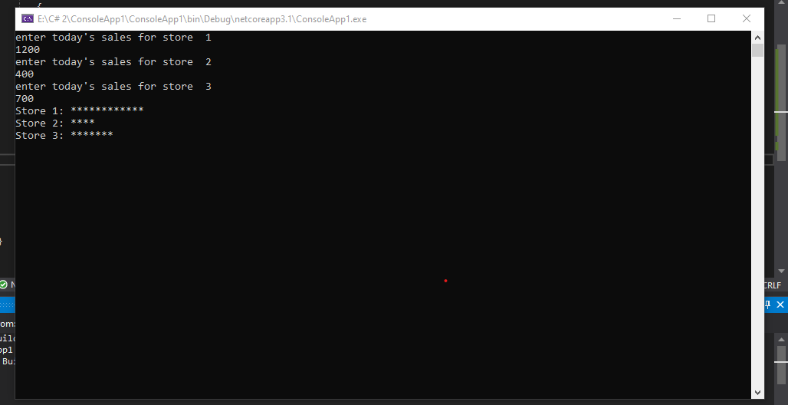

**ANSWER 9:**

**CODE:**

using System;

using System.Security.Cryptography.X509Certificates;

namespace ConsoleApp1

{

class Program

{

static void Main()

{

double total_hrs = 0, total_charge = 0;

double[] hrs = new double[3];

double[] charge = new double[3];

for (int i = 0; i < 3; i++)

{

Console.WriteLine("input car " + (i + 1) + " hours ");

hrs[i] = Convert.ToDouble(Console.ReadLine());

total_hrs += hrs[i];

}

for (int i = 0; i < 3; i++)

{

if (hrs[i] <= 3)

{

charge[i] = 20.00;

}

else if (hrs[i] > 3)

{

double y = hrs[i] - 3;

charge[i] = 20.00 + (5 * y);

}

total_charge += charge[i];

}

Console.WriteLine("Car\thours\tcharges");

for (int i = 0; i < 3; i++)

{

Console.WriteLine((i + 1) + "\t" + hrs[i] + "\t" + charge[i]);

}

Console.WriteLine("Total" + "\t" + total_hrs + "\t" + total_charge);

Console.ReadKey();

}

}

}

**OUTPUT:**

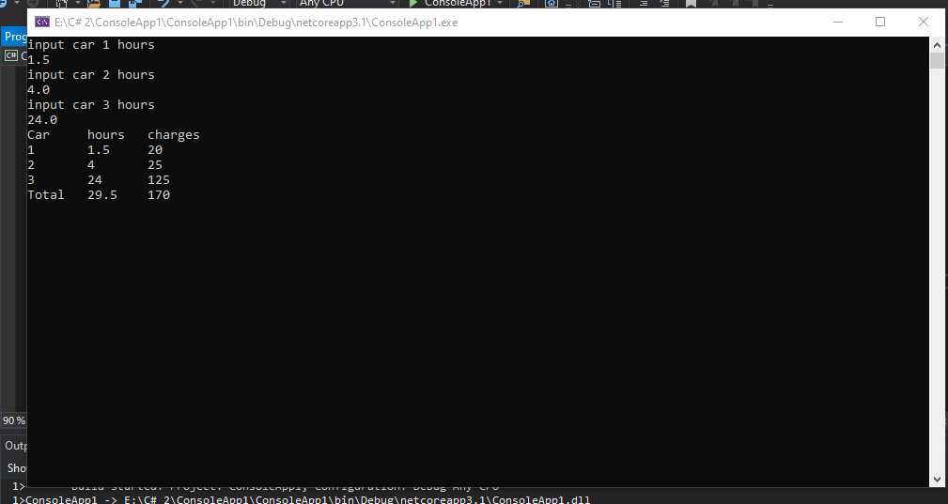

**ANWER 1:**

**CODE:**

using System;

using System.Security.Cryptography.X509Certificates;

namespace ConsoleApp1

{

class Program

{

static void Main()

{

for (int i = 1; i <= 3; i++)

{

for (int j = i; j < 5; j++)

{

Console.Write(" ");

}

for (int k = 1; k < (i*2); k++)

{

Console.Write(k);

}

Console.WriteLine();

}

for (int i = 2; i >=1; i--)

{

for (int j = 5; j > i;j--)

{

Console.Write(" ");

}

for (int k =1; k < (i*2); k++)

{

Console.Write(k);

}

Console.WriteLine();

}

for (int i = 5; i >= 1; i--)

{

for (int j = 5; j >i ; j--)

{

Console.Write(" ");

}

for (int k = 1; k < (i*2); k++)

{

Console.Write("*");

}

Console.WriteLine();

}

Console.ReadKey();

}

}

}

**OUTPUT:**

